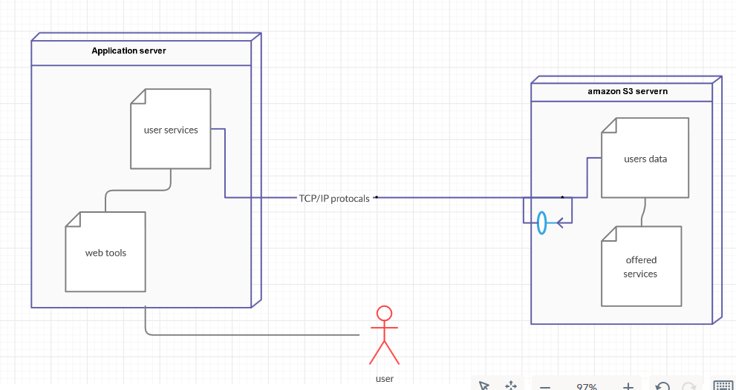

The user interacts with the application server to access the services offered by the website. The user data and services data are stored in the database and security server which is Amazon S3 server. TCP/IP protocols are used to provide the communication between the application server and the amazon S3 server.